Jane Amelia Balfour (nee Keir)

Jane was born on 8th January 1840, she was the middle child of Patrick Small Keir (09/05/1810 – 29/11/1889) and Amelia Frances Small Keir ( 01/11/1810 – 30/07/1894).

She had an older sister Catherine Menzies Keir (00/00/1837 – 22/04/1916) and a younger brother William Augustus Keir (16/02/1842 – 15/02/1879).

Jane married Francis Walter Balfour (08/01/1830 – 24/02/1909 ) on 23rd October 1866, when she was 26 years old, he was 36 years old. Upon her marriage she moved to Fernie Castle in Fife, the home of the Balfours
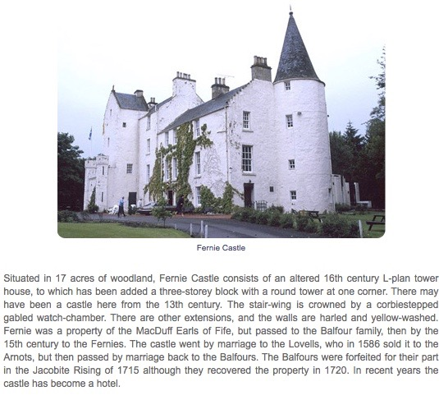

Jane and Francis had two children.
Francis Keir Balfour (25/08/1867 – 02/08/1926 )
William Keir Balfour (09/12/1869 – 10/09/1941)

Jane’s sister Catherine passed the Kindrogan Estate to Jane’s husband and eldest son Francis.

Catherine was still resident at Kindrodgan in 1901 but later moved to Redhu House Kirkmichael in her declining years.

Jane died on 9 February 1898, when she was 58 years old. She was buried in Monimail Old Churchyard Fife, in the same grave as her mother in law Margaret Balfour.

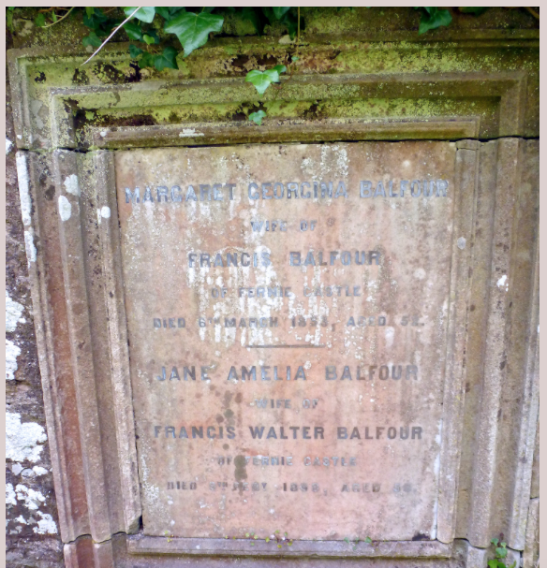

Francis Walter Balfour died on 24 February 1909 age 79, he was also buried at Monimail Old Churchyard Fife with his father.

