Abbeyhill House the Edinburgh residence of Lady Grace Menzies.

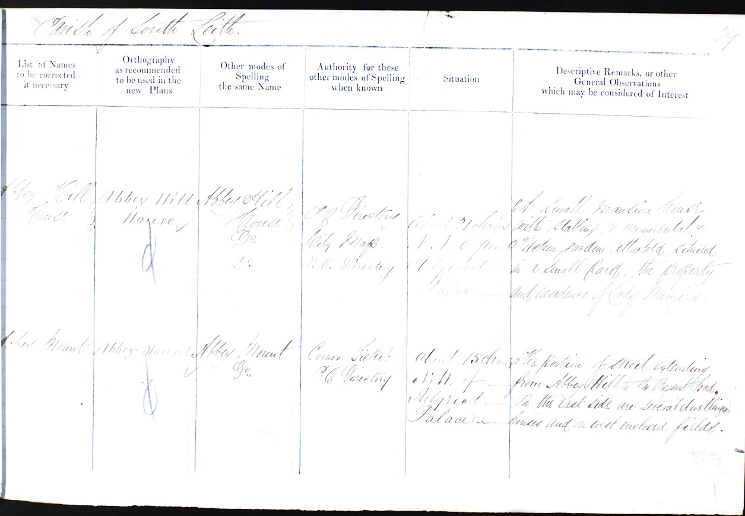

ABBEY HILL HOUSE P.O. [Post Office] Directory City Map
P. O. [Post Office] Directory 1852

[Situation] About 21 chains N.N.E [North North East] from Holyrood Palace
A Small mansion house with stabling, & ornamental, & Kitchen garden attached,
Situated in a Small Park;
the Property and residence of Lady Menzies.

Abbeyhill House once stood in the vicinity of Abbey Street and Lyne Street and was once home to Baron Norton. The estate stretched to Norton Park off Rossie Place but was demolished around 1870.
The Honourable Fletcher Norton (1744 – 1820) was the father of Grace Conyers Norton (Lady Menzies). He officiated as a The Baron of Exchequer of Scotland for forty-four years. (The Court of Exchequer was formerly a distinct part of the court system in Scotland, with responsibility for administration of government revenue and jurisdiction of adjudicate on cases relating to customs and excise, revenue, stamp duty and probate. In 1856 the Court of Session was designated as the Exchequer Court, which now carries out its judicial functions.)
He died at Abbeyhill in 1820.
His remains were taken to England and deposited in the family vault at Wonersh, near Guildford, in Surrey.
His son Fletcher Norton (1798 – 1875), Lady Menzies brother, succeeded as third Lord Grantley. The title was inherited from his Uncle.

The passage below was taken from “The Edinburgh Almanack and Scots Register for 1807” regarding Lady Menzies father Fletcher Norton.

This Edinburgh Almanack belonged to Fletcher Norton (1744-1820), second son of Fletcher Norton, first Baron Grantley, Speaker of the House of Commons. 'Fletcher Norton, Abbey Hill, Edinburgh' as he signs himself in this book, was appointed one of the Barons of the Scottish Exchequer in 1776 and set up residence in the Scottish capital. According to James Grant's book Old and New Edinburgh, Norton 'stood high in the estimation of all' as 'husband, father, friend, and master'. A founding member of the Royal Society of Edinburgh, Norton was a supporter of Scottish culture, playing a key role in ensuring the publication of Albyn's Anthology, an important collection of Scottish music. Norton gave his name to East and West Norton Place, Abbeyhill, the streets now located on the site of his old Edinburgh home. This almanac, whose blank pages were used by Norton to keep a record of his expenditure, provide an interesting insight into the daily life of a member of Edinburgh's social and cultural elite in the early 19th century, recording the 18 shillings spent on tooth powder, and the £2.9.0 spent on a chaise to London, among other notes. Our perception of movement between England and Scotland during this period is largely one of Scots emigrating - this book bears witness to an Englishman who successfully moved to Scotland and integrated himself with its cultural life.

The Norton Estate at Abbey Hill
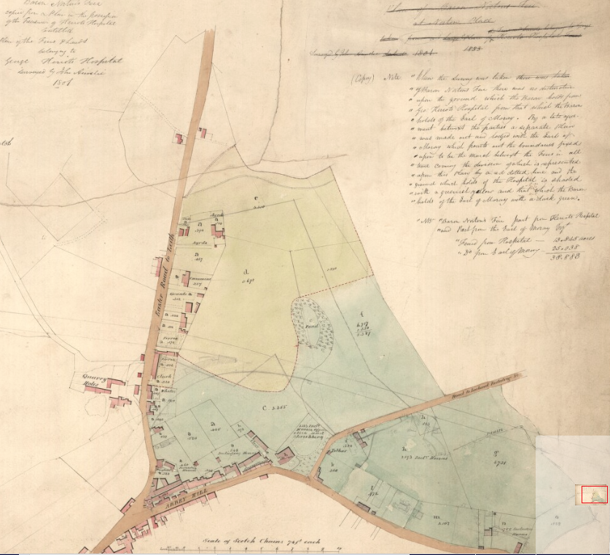

The Introduction of the Abbeyhill Colonies
The collapse of tenements on Edinburgh’s High Street on the 24th November 1861, when 35 people were killed and a further 100 injured brought the issue of the condition of buildings in the Old Town into sharp public relief.
The Victorian improvement schemes in the Old Town, in which the older tenements were replaced with new buildings, often in a Baronial style, were seen as a solution to the problem.

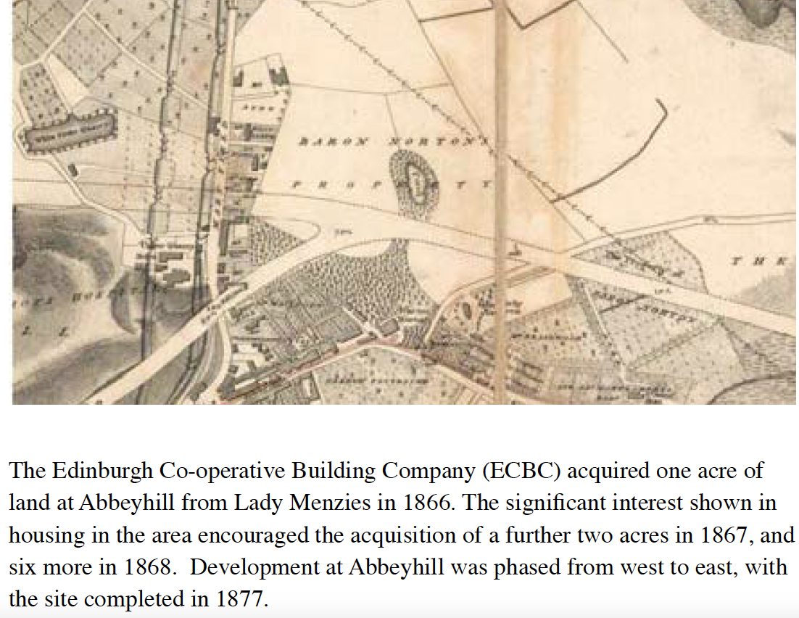

The Colonies form a rectangular site and are composed of seven streets: Maryfield, Maryfield Place, Alva Place, Lady Menzies Place, Regent Place, Waverly Place and Carlyle Place (West to East).

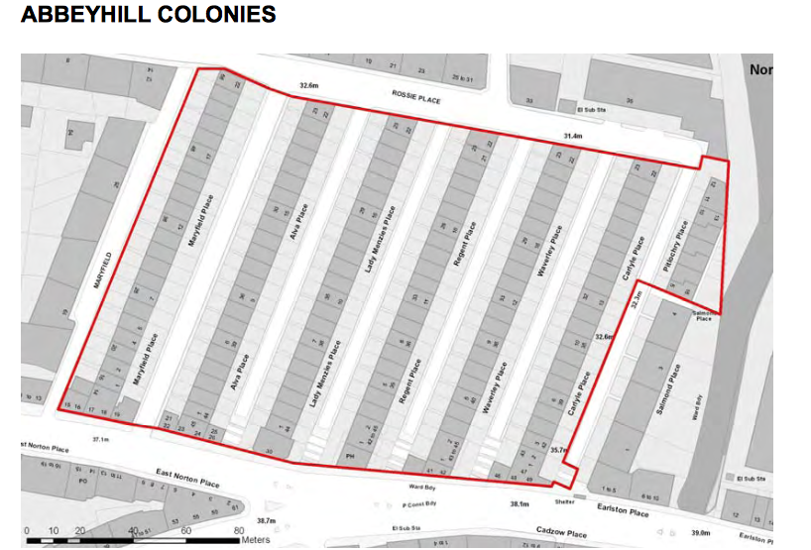

The Colonies after Abbey Hill House was demolished in 1870.

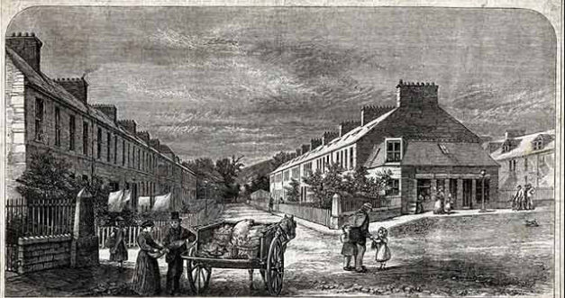
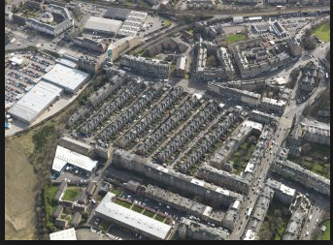
Abbey Hill Colonies Today

