Alva and Hangingshaw Estates

Mr James Johnstone (04.07.1801 – 24.02.1888) inherited these estates on the death of his father James Raymond Johnstone (04.06.1768 – 07.04.1830).

Alva is in Clackmannanshire. Hangingshaw is in Selkirkshire.

The family fortune was created by his grandfather John Johnstone (28.04.1734 –10.12.1795). He was an official of the British East India Company. He was described as a shrewd and unscrupulous businessman, he survived several scandals. He returned to Scotland from India with great wealth and purchased Alva in 1755.
He extended the house considerably in 1820 adding a West Wing, Stables, Offices, Ice House and a Mausoleum. This was due to having a large family of 16 children. James Raymond Johnstone was the eighth child and first male heir.

The house was passed to Caroline Elizabeth Johnstone in 1890 on the death of her brother John Augustus Johnstone. They were the children of James Johnstones first marriage. Upon her death in 1929 the house could not be sold. It was destroyed by being used for military practice during the second world war. In recent years a modern and slightly more modest Alva House has been constructed to the east of the town.

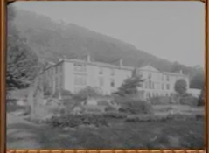
Alva House
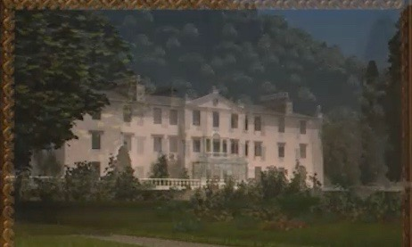
Alva House

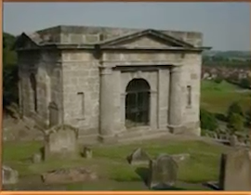
The Johnstone Mausoleum
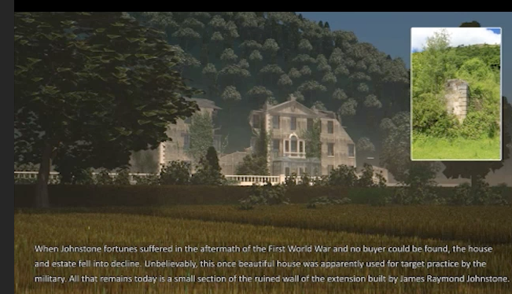

The previous owners of Alva, Sir John Erskine found silver in Alva Glen. The silver ore that emerged was the purest ever found in Great Britain and Erskine made a fortune mining it before the vein of ore ran out. In the years around 1710, silver to the value of £4000 per week was emerging from the mine. That was a vast amount of money at the time.

