Bisham Abbey Manor House
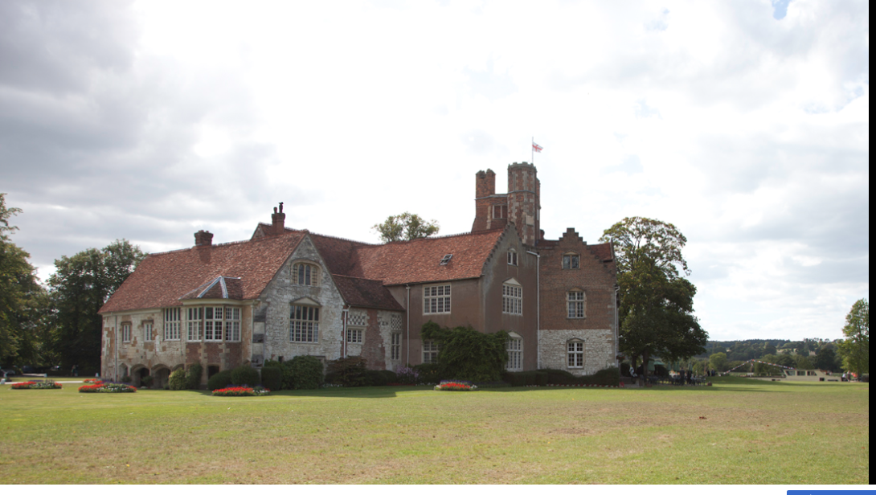
This was the home of George Henry Vansittart MP for Berkshire. He lost his seat 23 April 1859.

William visited here when he was at Cambridge University.

This Manor House was part of Anne of Cleeves divorce settlement from Henry VIII.

