Charlotte Square Edinburgh

The majority of Charlotte Square was designed, in accordance with a plan, by celebrated New Town architect Robert Adam. Adam died in 1792 without seeing his vision completed. Completion was eventually achieved in 1820.

From the very inception of Charlotte Square, in 1791, it was anticipated it would be one of the desirable addresses in Edinburgh. As the Victorian era commenced, the square was increasingly occupied by the elite of the middle class: legal and medical professionals.

The garden was originally laid out as a level circular form by William Weir in 1808. The central open space being a private garden, available to owners of the surrounding properties.

In 1861 a plan was drawn up for a larger, more square garden, The large statue in the middle of the gardens commemorates Prince Albert, the Royal Consort to Queen Victoria, and was unveiled by Victoria herself.
Heavy wrought-iron fencing closed off the gardens. The railings around the gardens were removed in 1940 as part of the war effort. The current railings date from 1947.

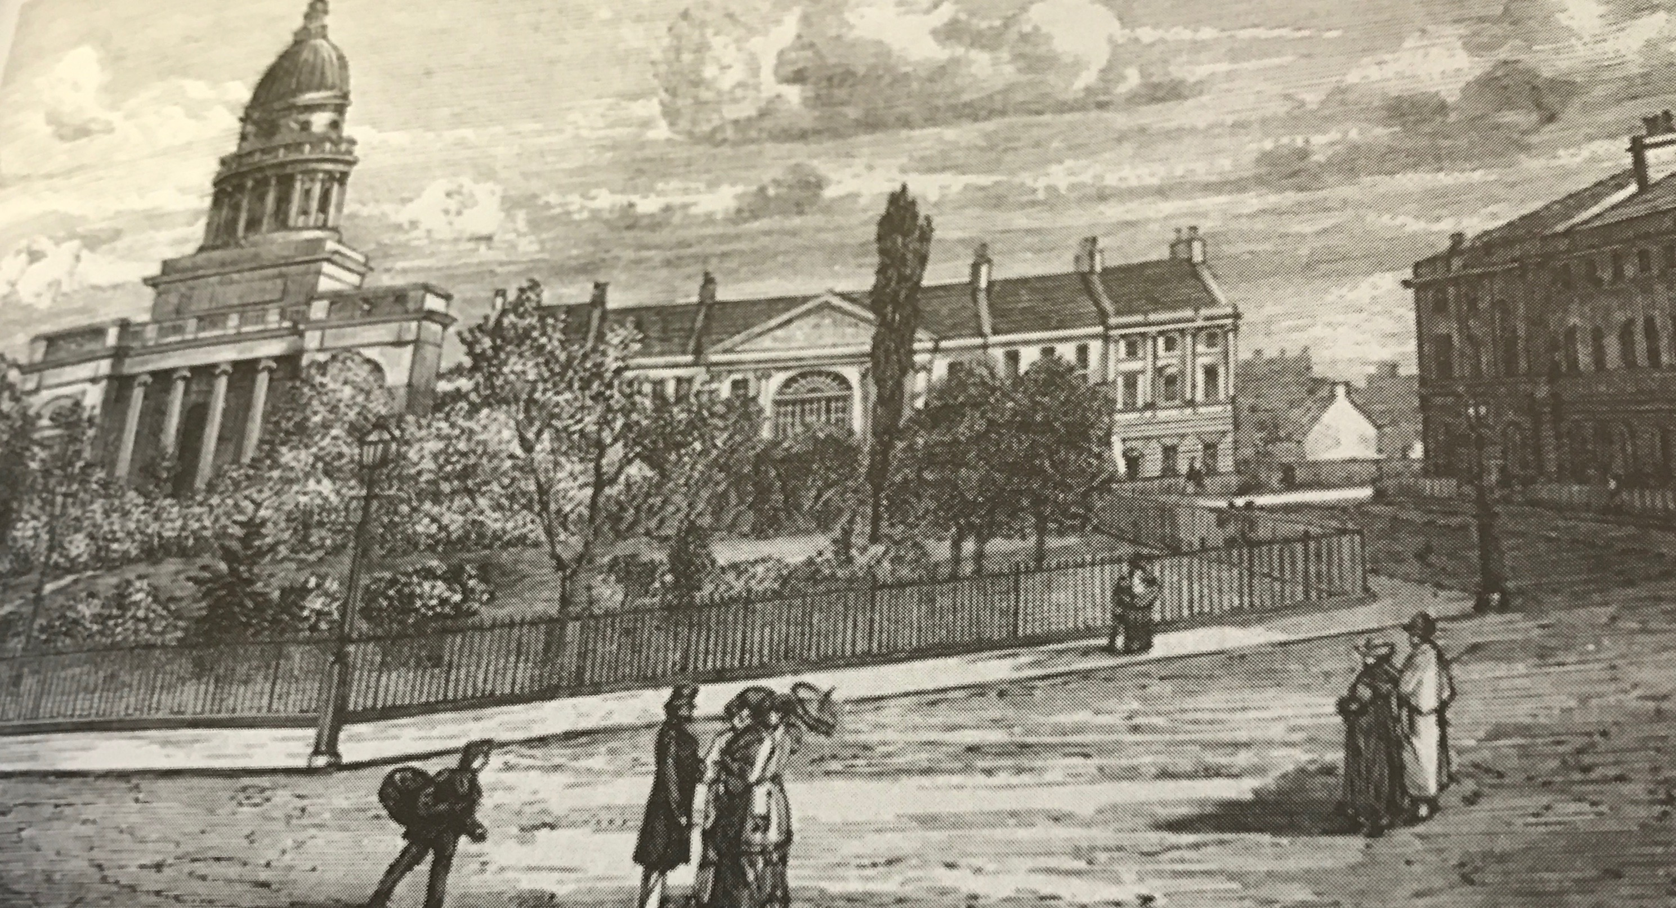
This picture was taken in the mid1870s.

No.6, Bute House is now the official residence of the first minister of Scotland
. 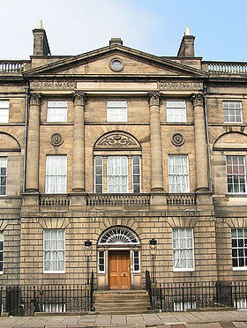

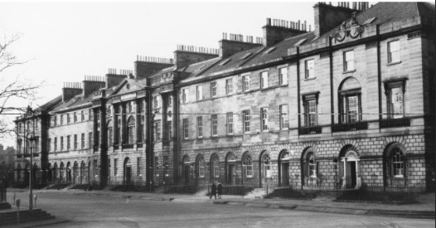
Number 32 is four houses down on the left of Bute House which is in the centre.

The National Trust's Georgian House at 7 Charlotte Square offers a window into 18th century living, with its neo-classical design and period furnishings on 3 floors.
The opulence of the interiors matches the grandeur of the exterior. This is a picture of the dining room at no.7.
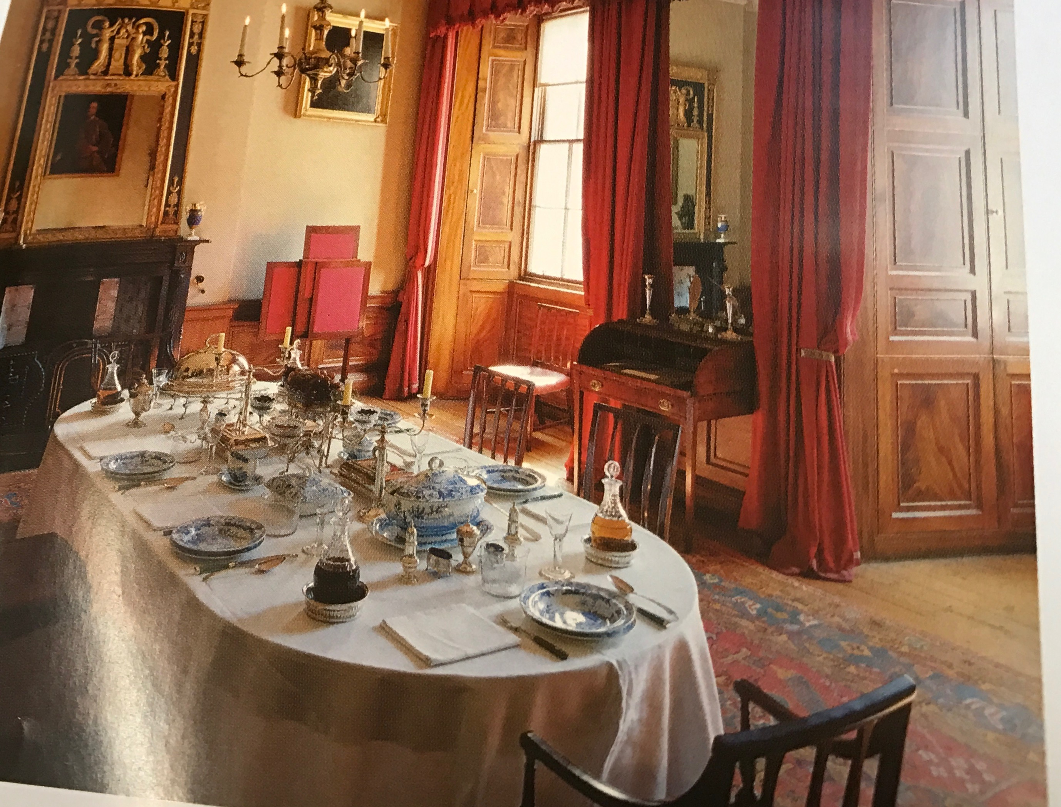

Charlotte Square Ghosts
There are many legends concerning hauntings in Charlotte Square. A ghostly piano has been heard on quiet nights and a hooded figure has been seen strolling around the square, in 18th century clothes. There is also said to be a ghostly carriage pulled by horses that appears when the square is free of modern traffic.

