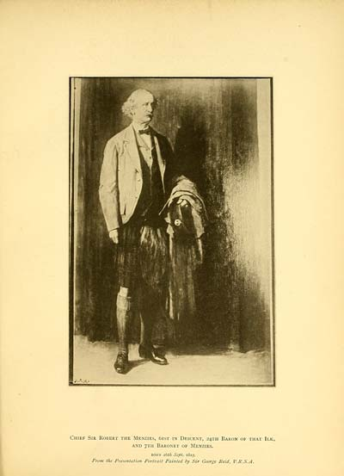

Chief Sir Robert the Menzies, 6ist in Descent, 24TH Baron of that Ilk,
and 7TH Baronet of Menzies.
BORN i&th Sept. 1817.
From the Presentation Portrait Painted by Sir George Reid, P.P.S.A.

Uncle Bob mentioned in Jane Amelia Keir’s letters

Step brother to the children’s mother Amelia Frances Small Keir

