Croftinloan
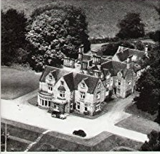
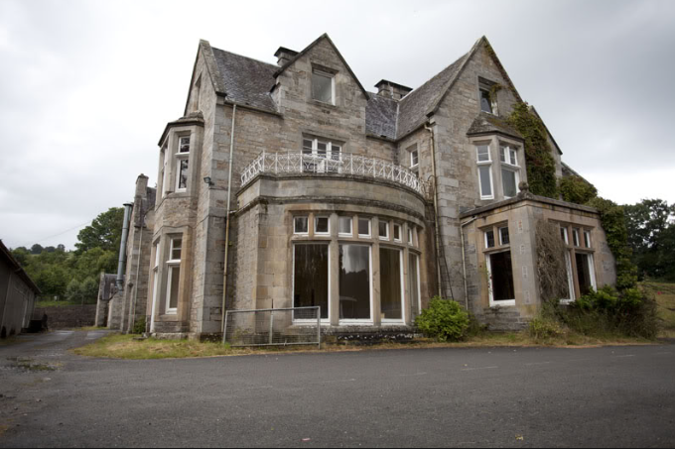
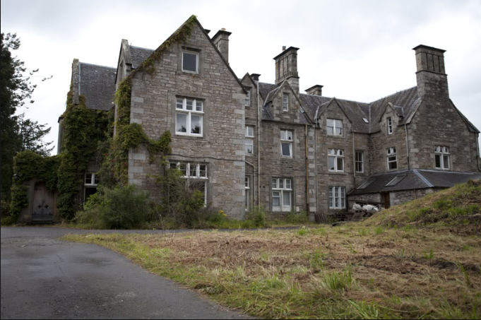
Croftinloan was for over 50 years in the hands of the late Admiral Jack Murray, whose wife was a daughter of Sir Neil Menzies of Weem. The childrens mother’s sister, Aunt Catherine.

From Scottish Ordance Gazetter
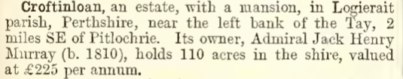

Queen Victoria travelled north to Croftinloan in 1865 on her way to Strathardle.

Croftinloan became a school in 1936.

The House was demolished in 2013 for a housing development.

