Kindrogan

In the Children’s Era
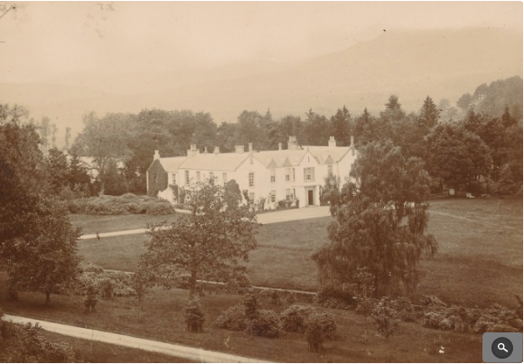
Kindrogan House

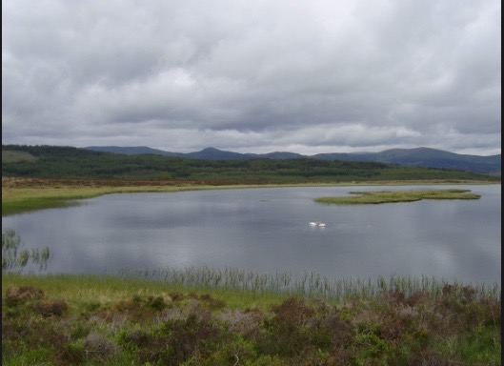
Loch Curran where Grandpapa use to take his boat to fish.
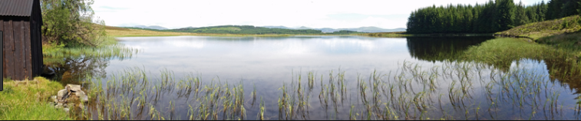
Loch Curran Boat House

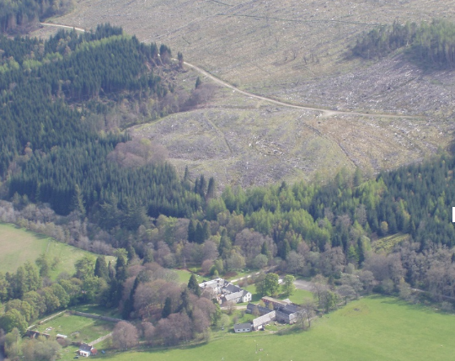

Kindrogan today as a Field Centre

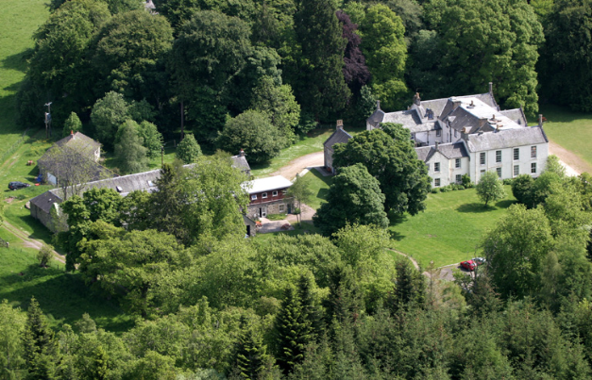
Kindrogan Field Centre

Kindrogan Estate was anciently the property of the Robertson and Reid families.
Later the Estate was owned by the Small Keir family.
In the 1880s Patrick Small Keir Esq. (b. 1810 –d 1889), held the 10,000 acre (40 km2) estate, valued at £2445 per annum.
Patrick Small Keir Esq was proprietor until his death in 1889. Miss Catherine M Keir the elder daughter remained as occupier until 1901, she remained unmarried. Catherine passed Kindrogan to her sister Jane Amelia Keir and her husband Captain Francis Balfour, of Fernie Castle in Fife, when it became the property of the Balfour Family. Catherine, due to old age, moved into the local village of Kirkmichael and lived at Redhu House until her death in 1916. She was buried in the Kindrogan Family graveyard.

Dirnanean was purchased in 1926, by Jane Amelia’s grandson Francis Balfour. Following his marriage to Katherine Dolby they moved in 1930 to Dirnanean. Kindrogan was then let to Sir George and Lady Dolby for their summer home. The Balfours returned to Kindrogan after WWII, and remained in residence until 1960. The estate was then purchased by the Forestry Commission and sold to the current owners, the Scottish Field Studies Association, in 1963.

The family or laird's graveyard lies on the slopes of Kindrogan Hill. Beside the path running from the house to the Enochdhu Lodge, a plaque records that Queen Victoria once stopped here for tea, on an excursion from Dunkeld to Spittal of Glenshee.

Another eminent visitor to Kindrogan House was Lord Cockburn, a circuit judge, and frequent guest of the Keirs. The family were often visited by the gentry of Scotland.

The 1850s O.S. map shows a bowling green to have been situated near the walled garden, in the sunken area running down to the River Ardle. A summer house lay on a path down from the family burial ground.

The house also had a curling pond, a loch with a boathouse and an island. The gardens and shrubbery were also a feature of a well loved home.

The Design of the House
Early 19th century incorporating earlier fabric (possibly mid 18th century) and with later additions and alterations. Substantial 2-storey, crowstepped house with courtyard to rear, crowstepped gabled dormer heads and consoled doorpiece. Harled with painted stone margins, and random rubble with large squared rubble granite quoins.
A crow-stepped gable, stepped gable, or corbie step is a stairstep type of design at the top of the triangular gable-end of a building. The top of the parapet wall projects above the roofline and the top of the brick or stone wall is stacked in a step pattern above the roof as a decoration and as a convenient way to finish the brick courses.
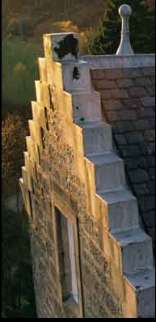
SE Principal Elevation: symmetrical. Advanced gabled bay to centre at ground with keystoned, plastered doorpiece, moulded scroll consoles supporting fielded blocking course and 2-leaf panelled timber door, full-width cornice above giving way to tripartite with narrow lights to returns at both floors and tiny round-headed light in stepped and finialled gablehead. Recessed flanking bays with windows to each floor, those to 1st floor with blind shield to gabled dormerheads; outer bays with window to each floor and dominant corbelled polygonal gablehead stacks.
SW Elevation: regularly-fenestrated 10-bay elevation with polygonal stack to gable at bay 5, and 4 taller bays to right.

NE Elevation variety of elements to 6-bay elevation including gable as above to outer right and blocked window to each floor at outer left. Courtyard (see below) accessed from outer right.
NW Elevation: asymmetrically-fenestrated rubble elevation with variety of elements including timber door to left and projecting harled bay to outer right.
Courtyard: variety of elements to altered service courtyard with rear of principal elevation to SE probably containing earliest fabric at centre bays, raised basement and crowstepped gablets breaking eaves. Rubble block to NW also early.
Mainly 4-, 12-, 15-pane and plate glass glazing patterns in timber sash and case windows. Graded grey slates. Coped ashlar stacks with polygonal cans; ashlar-coped skews with moulded skewputts.
Interior: principal SE block retains good decorative details and later 19th century scheme including decorative plasterwork cornicing, fluted reveals and panelled shutters; architraved doorways with scroll-consoled cornices. Part-cantilevered dog-leg staircase with decorative cast-iron balusters and segmentally-arched landing; honeycomb ceiling and plain cornicing to dining room (ground right); Tudor-arched marble fireplace with fine cast-iron fireback decorated with crowns and fleur-de-lis to ground floor left.
Walled Garden and Ancillary Building: rectangular-plan, flat-coped rubble walled garden to NE with slated rubble, symmetrical, single storey and attic, 3-bay garden house abutting to NW.

