Kinmonth Estate

Patrick Small Keir (1781 – 1860) inherited the Kinmonth Estate upon the death of his mother’s, Margaret Small (1747 – 1836), brother Patrick Keir in 1810.

The family the surname of Small – Keir was used from that date.
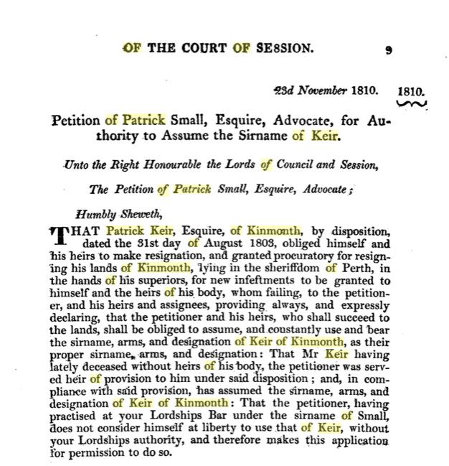
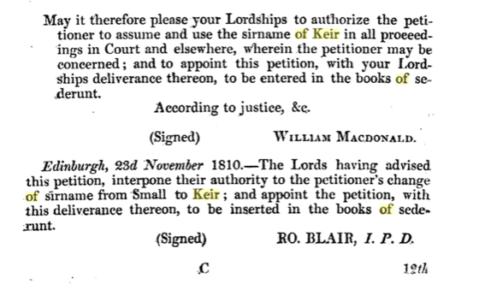

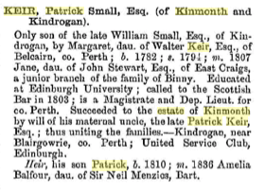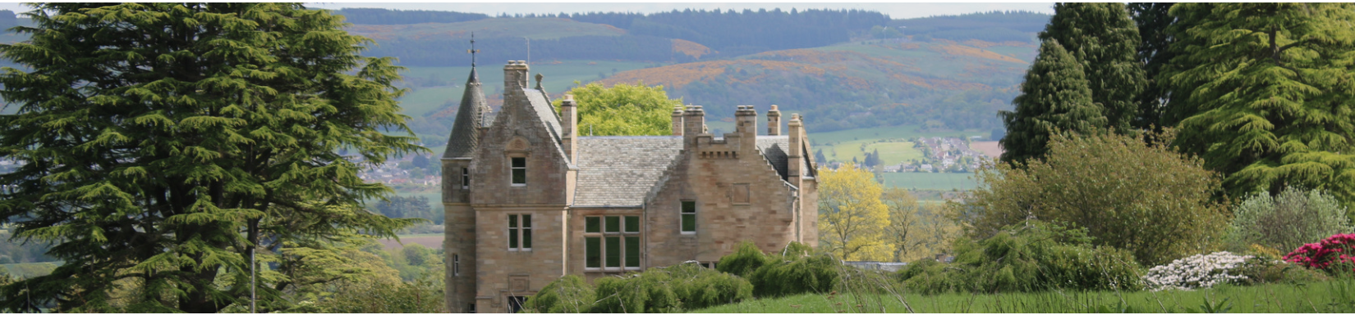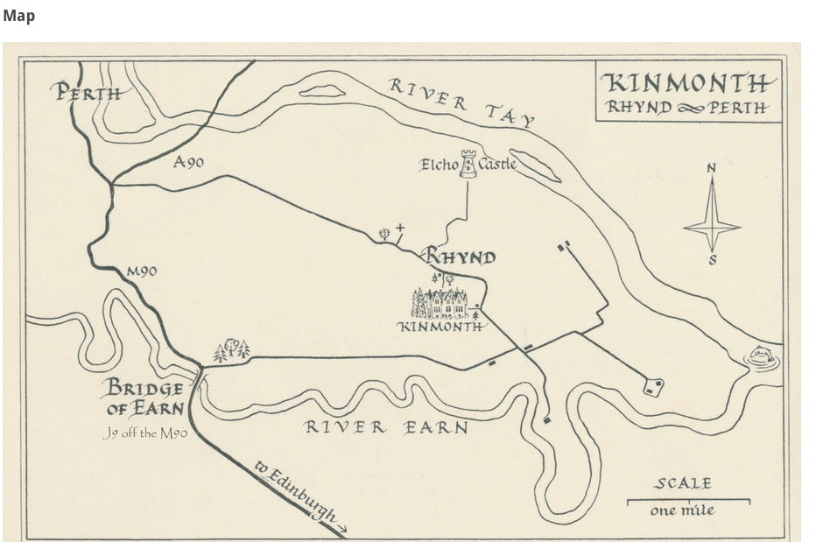

From the Kindrogan Rent Book 1853 to1863

The Mains of Kinmonth was rented by Mr David Tod for
£410 10s per annum. He also paid £70 per annum for the Orchard crop and £6 for the fishing.

The Keir family purchased Kinmonth in 1683.

Patrick Small Keir (1810 – 1889) of Kindrogan sold Kinmonth to the Trustees of Sir George Simpson of the Hudson Bay Company in 1864.

