Lady Jane Hay

Jane was born in Geneva, Switzerland on 1 April, 1830, but she was brought home to Scotland to be baptised on 25 May, 1830. There is a record of her baptism in the parish church of Yester, East Lothian. John, her brother, was also born in Geneva in 1827, but all the other children appear to have been born in Scotland, there was fourteen of them in all.
Her father was George Hay, Marquis of Tweeddale and her mother Susan Georgina Montagu. The family home was Yester House, Gifford, East Lothian
So Jane grew up in a busy household. She was the sixth daughter of the fourteen children.
In 1841 Census of Scotland Jane is living with her large family and servants in Yester House, East Lothian.
In 1851, Jane is living with her mother in Upper Grosvenor Street, London, her brother John (23) and her younger sisters, Julia (19) and Emily (14), together with a governess, a cook, 2 butlers, 2 footmen, 2 housemaids, a page, 2 kitchen maids 3 ladies maids and a still room maid.

In June 1863, she married Richard Chambré Hayes Taylor of Dowdstown House in the parish of St. Peter’s, Pimlico. I can find no reference as to how they met.
She had five children.
Jane died on 13 Dec. 1920, aged 90. The application for probate lists her address as 16 Eaton Place, London.
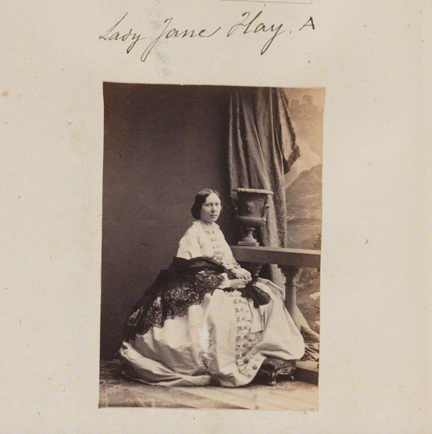
Lady Jane (neeHay) Taylor 1860

Her brother the Colonel
Colonel Arthur Hay, 9th Marquis of Tweeddale
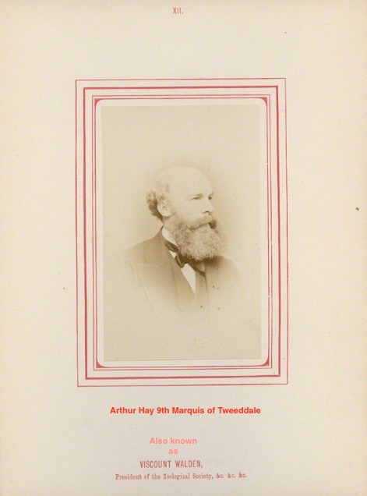
(9 November 1824 – 29 December 1878), known before 1862 as Lord Arthur Hay and between 1862 and 1876 as Viscount Walden, was a Scottish soldier and ornithologist.
He was born at Yester House near Gifford, East Lothian, the son of General Sir George Hay 8th Marquis of Tweeddale and his wife, Lady Susan Montague. He was sent to university in both Leipzig and Geneva.
Training in the military he received a commission in the British Army in 1841. He rose to be a Colonel in the Grenadier Guards. He served as a soldier in India and the Crimea. He succeeded his father in the marquisate in 1876. He died at Chislehurst, and was succeeded by his brother.
Hay purchased a lieutenancy in the Grenadier Guards in 1841. He purchased a captaincy in 1846 and was promoted lieutenant colonel without purchase in 1854 and Colonel in 1860. In 1866 he transferred to the 17th Lancers.
He was president of the Zoological Society of London from 16 January 1868. He had a private collection of birds, insects, reptiles and mammals and employed Carl Bock to travel to Maritime Southeast Asia and collect specimens. Tweeddale described about 40 species collected by Bock for the first time and was elected a Fellow of the Royal Society in 1871.

He died at Walden Cottage in Chislehurst, London on 28 December 1878.

