From Housing Survey 1853
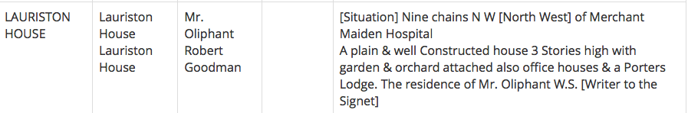

George Chalmers (1773-1836), a plumber in Edinburgh, left the residue of his estate, amounting to around £30,000, to the Dean and Faculty of Advocates for the purpose of founding a ‘New Infirmary or Sick and Hurt Hospital’. In 1854, once the funds had accumulated to £70,000, Lauriston House was purchased with seven and a half acres of land behind it extending down to the meadows. On part of the land the hospital was begun in 1860, and Chalmers Street was formed on part of the ground which was then feued for housing development. Lauriston House was let as a school.

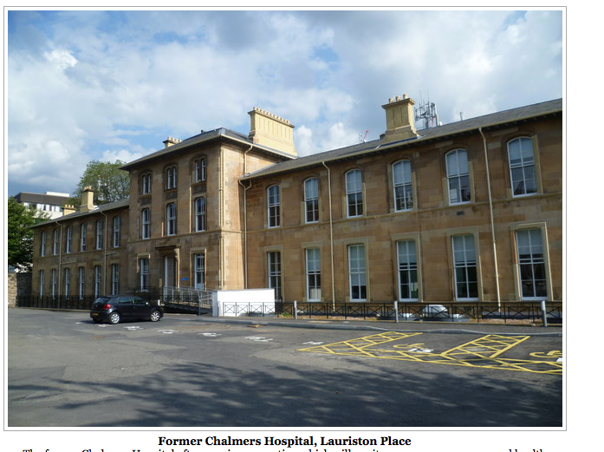

Taken from a housing O.Survey 1853. Mr Goodman lived in the Lodge of Lauriston.

