Lord Henry Cockburn ( 1779 - 1854)

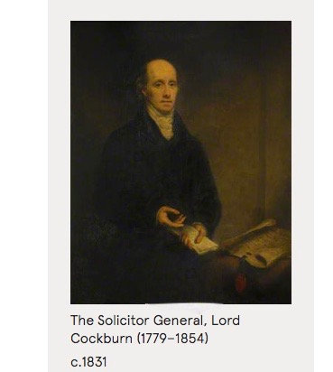

Henry Thomas Cockburn of Bonaly, Lord Cockburn was a Scottish lawyer, judge and literary figure. He served as Solicitor General for Scotland between 1830 and 1834.
Born: 26 October 1779, Scotland
Died: 26 April 1854, Bonaly
Education: Royal High School, Edinburgh, University of Edinburgh

Lord Cockburn was a frequent visitor of the Keirs at Charlotte Square and Kindrogan.

Lord Cockburn lived at number 14 Charlotte Square this is on the west side. The Keirs lived at number 32 on the north side of the square.
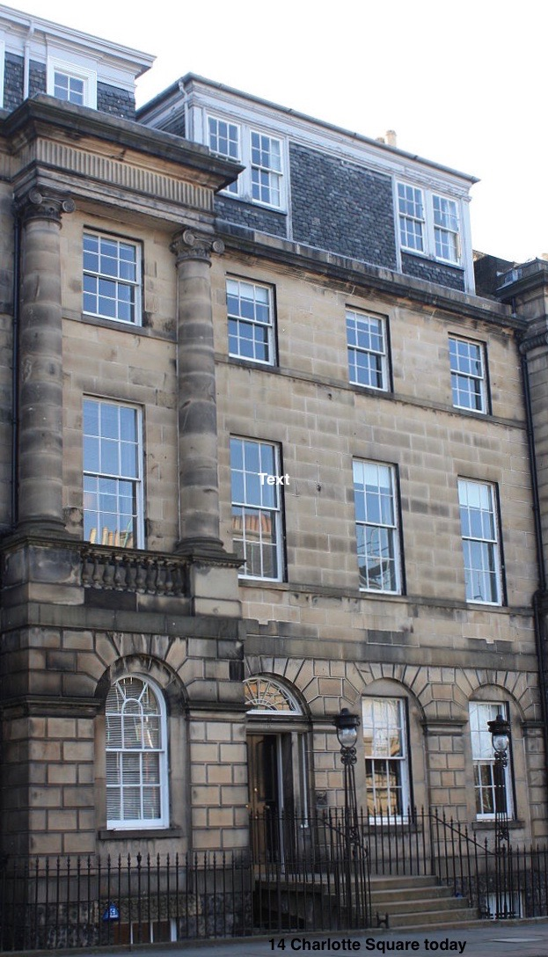
14 Charlotte Square today
Cockburn married Elizabeth Macdowall (Glasgow, Lanarkshire, 1 March 1786 – 1857), daughter of James Macdowall and second wife Margaret Jamieson, in Edinburgh, Midlothian, on 12 March 1811. As was common in the period he had both a town house and country house. The country house was at Bonaly, on the south-west edge of Edinburgh. His town house was a hugely impressive house at 14 Charlotte Square, designed by Robert Adamand lying at the heart of the fashionable west end of the city. They had five sons and five daughters:

Cockburn entered the Faculty of Advocates in 1800, and attached himself, not to the party of his relatives, who could have afforded him most valuable patronage, but to the Whig party, and that at a time when it held out few inducements to men ambitious of success in life. He became a distinguished advocate, and ultimately a judge. He was one of the leaders of the Whig party in Scotland in its days of darkness prior to the Reform Act of 1832, and was a close friend of Sir Thomas Dick Lauder.
On the accession of Earl Grey's ministry in 1830 he became Solicitor General for Scotland. During his time here he drafted the First Scottish Reform Bill. In 1834 he was raised to the bench, and on taking his seat as a Judge in the Court of Session he adopted the title of Lord Cockburn as a Scottish Lord of Session.

Cockburn contributed regularly to the Edinburgh Review. In this popular magazine of its day he is described as: "rather below the middle height, firm, wiry and muscular, inured to active exercise of all kinds, a good swimmer, an accomplished skater, an intense lover of the fresh breezes of heaven. He was the model of a high-bred Scotch gentleman. He spoke with a Doric breadth of accent.

Cockburn was one of the most popular men north of the Tweed.

