Loretto School

Loretto is the boarding school in East Lothian.

William Augustus Keir attended this school from 1854 to 1858.

Pinkie House was formerly the country seat of the abbots of Dunfermline, and the tower house was built some time in the 16th century on the site of the Battle of Pinkie. In 1597, following the Reformation, it passed to Alexander Seton. He served as James VI's chancellor, and was created Earl of Dunfermline in 1605. The young Prince Charles, later Charles I, lived here as a boy, after his father's move to London at the Union of the Crowns in 1603. He slept in what is still known as "The King's Room". In 1607 Seton married his third wife, Margaret Hay of Yester, and from 1613 set about expanding the house, adding a long wing to the south, and decorating the interior:
In 1694 the property passed to the Hays, the Marquess of Tweeddale adding a door to the east front. In 1745, following victory at the Battle of Prestonpans, Charles Edward Stuart, the "Young Pretender", stayed here, as well as using the building as a field hospital. In 1778 the Hays sold the building to Sir Archibald Hope, 9th Baronet of Craighall, who made further alterations, and added a stable block. Extensions were carried out in 1825, designed by William Burn.

The school was established in 1827 as a boy’s only boarding school and claims to be the oldest boarding school in Scotland.
The grounds were around 85 acres
It was founded by the Reverend Thomas Langhorne, his son Thomas would have been headmaster when William attended.

The school motto:
Spartam nactus es, hanc exorna
“You were born with talents: develop them” or “Develop whatever talents you have inherited”.

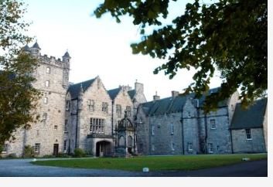
Pinkie House
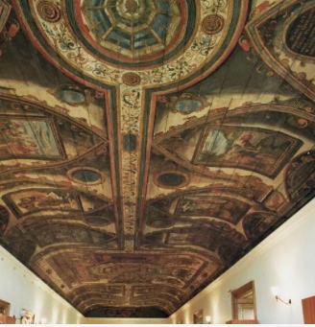
The Painted Gallery
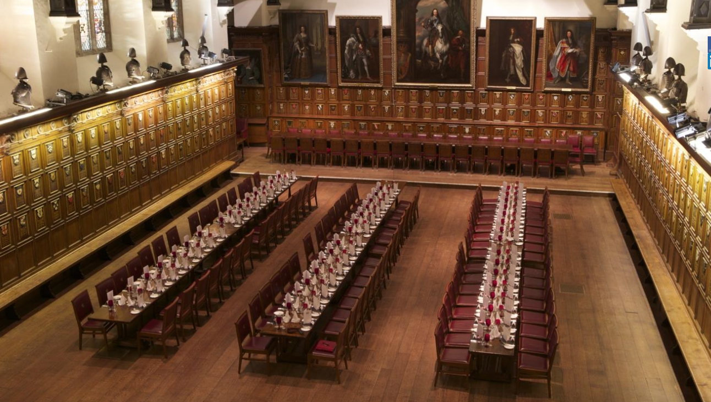
The Old Dining Room

