Prestonfield House on the edge of Edinburgh owned by the Dick Family for generations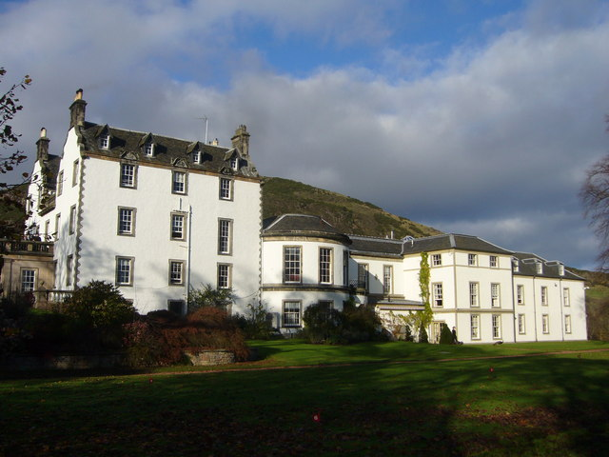

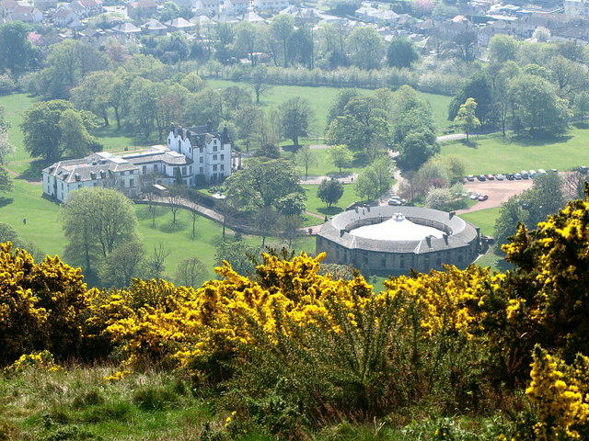
History[
In 1751 the house was inherited by Sir Alexander Dick from his elder brother William and his eccentric wife Anne Dick. The new estate remained in the family's possession for many generations, and they played host to many great thinkers of their times, including David Hume, Benjamin Franklin, Dr Samuel Johnson, and Allan Ramsay. The Dick family continued to modify and improve the estate, adding paintings, a grand new staircase with reception rooms, and a porte-cochère. Most notably, the stable house was built in the 19th century, as designed by James Gillespie Graham. As later generations of the family spent less and less time at the estate, no further remodelling took place.

In 1852, according to the OS survey, the property was occupied by Mr Brown whose occupation was a Recorder.

