Raigmore Manor House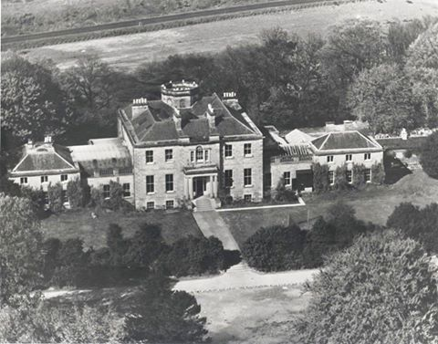
Grace Menzies, daughter of Sir Neil Menzies, 6th baronet, the childrens young step aunt, married Aeneas Mackintosh (07/09/1819 – 18/06/1900) of Raigmore Inverness on 12/03/1856.
He inherited Raigmore House in 1845 on the death of his father. He was educated at Oxford University. He was a J.P. and Deputy Lieutenant of Inverness-shire, Lieutenant-colonel of the 1st Inverness Volunteer Artillery, and Lord of the Barony of Raigmore.
At the 1868 general election Mackintosh was elected Member of Parliament for Inverness Burghs. He lost the seat in 1874.
Mackintosh died at the age of 80.
Raigmore House was demolished in 1960s.

