Rannoch Estate owned by the Menzies Family

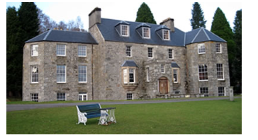

This is one of the Scottish estates which has entirely disappeared.
The father of Sir Robert Menzies, Sir Neil Menzies who died in 1844, had settled his Rannoch estates on his widow, a daughter of Baron Norton, and this her fiery- tempered son left a mere 32,784 acres, fiercely resented. He kept law-suits going against her for 20 years without avail. She was known in Rannoch as “an Leddi Ruadh” so probably had a red devil of a temper also.
As Sir Robert was an eminently litigious in numerous other directions as well, this may have been exceedingly gratifying to lawyers but effectively ruined the estate. He came into Rannoch at his mother’s death (1878) but a few years after his own (1903) the estate, heavily burdened with debts was sold to an Ipswich brewer. The parish historian summed up Sir Robert: “He was a strict game-preserver and strongly asserted his rights as a landlord. Nevertheless in his own way he could be kind to his tenants and dependants and to such others as knew how to flatter him.”

