Sir Neil Menzies 6th Baronet of Menzies

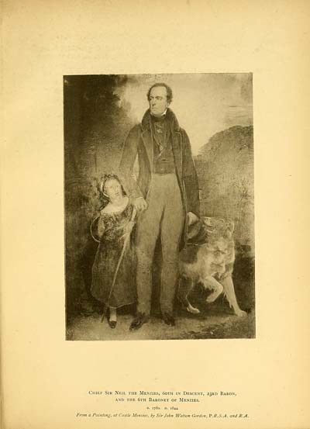
The childrens maternal Grandfather

Sir Neil Menzies succeeded to the chiefship, estates and baronetcy of Menzies on the death of his father Sir Robert Menzies, 5th baronet of Menzies, who died on 8th March 1813. Sir Neil was born on 16th August 1780, before his father had any hopes of the Baronecy, as Sir Robert, the third baronet, was still living, with several other heirs who came before him.

Sir Neil was educated for the Bar, and was in the year 1801 elected a member of the Faculty of Advocates, of which, on his accession to the title and estates of Menzies became an honorary member, which he retained during life.

He first married on 6 June 1808, Emelia Balfour, daughter of the Hon. Francis Balfour of Fernie, she was the childrens maternal grandmother. They had two daughters Catherine and Amelia. Emelia died giving birth to Amelia on 01/11/1810.

On 3rd December 1816 he married the Hon.Grace Charlotte Conyers Norton eldest daughter of Fletcher Norton, Lord Grantley. They had four children two sons and two daughters.
Robert, Fletcher, Caroline, and Grace.

In the portrait with him is his youngest daughter Grace. He did not wear the highland dress in the portrait due to slight lameness brought about by a kick from a horse a few years before.

