Yester House
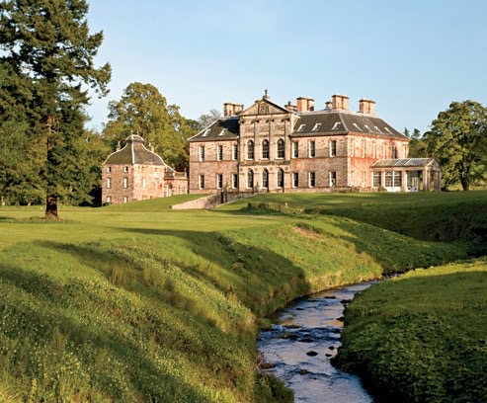
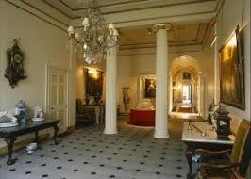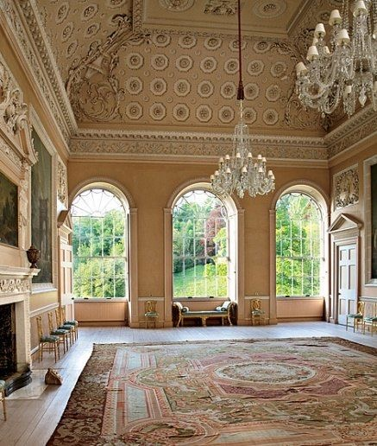

Yester House is an early 18th-century mansion near Gifford in East Lothian, Scotland. It was the home of the Hay family, later Marquesses of Tweeddale, from the 15th century until the late 1960s. Construction of the present house began in 1699, and continued well into the 18th century in a series of building phases.

This was the childhood home of Lady Jane Hay and her brother Colonel Arthur HayArthur, they were from a family of fourteen children.

