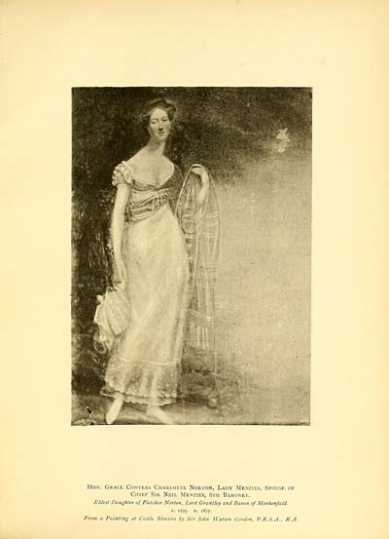

Hon. Grace Conyers Charlotte Norton, Lady Menzies, wife of

Chief Sir Neil Menzies, 6th Baronet.

Eldest Daughter of Fletcher Norton, Lord Grantley and Baron of Markenfield.

b. I795. d. 1877.

From a Painting at Castle Menzies by Sir John Watson Gordon, P. U.S.A., R.A. In which LadyMenzies wore her wedding dress.

Lady Menzies mentioned in Jane Amelia Keir’s letters. She was step grandmother to the children, mother to Uncle Robert and Uncle Fletcher Menzies, Aunt Caroline and Gracie and step mother to the childrens mother.