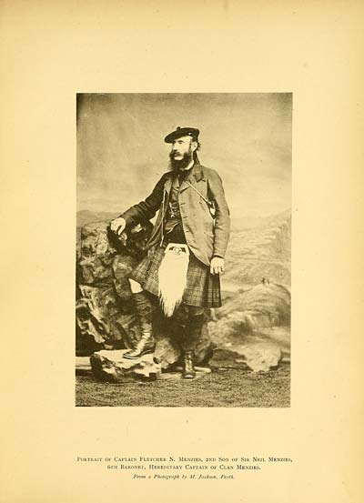

Portrait of Captain Fletcher N. Menzies, 2nd Son of Sir Neil Menzies,
6th Baronet, Hereditary Captain of Clan Menzies.
From a Photograph by M. Jackson, Perth.

Uncle Fletcher mentioned in Jane Amelia Keir letter

Step brother to the children’s mother Amelia Frances Small Keir

