Kindrogan Rent Book from 1853 to 1863

The Small Keirs were a wealthy family who owned Kindrogan.
Below is an indication of the rents collected per annum.
Annually amounting to approximately £1,700 plus. The equivalent value in 2017 amounted to £203,163.

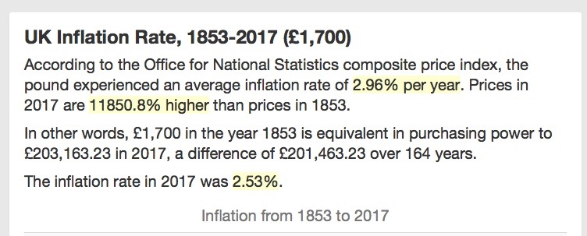

The layout of the rent book was left hand side the rent due, the right hand side the amount collected.

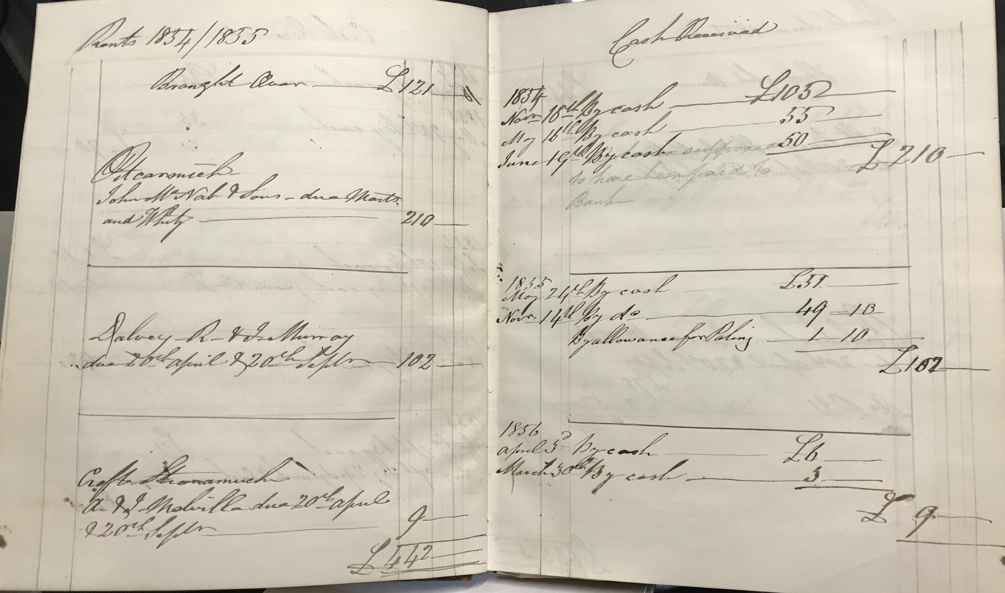

The rents were due on various dates:
Whitsuntide – 7th Sunday after Easter
Martinmas – Feast of St. Martin 1st November
Lammus – 1st August
Candlemas – 2nd February

The handwriting appears, when compared to the handwriting from Grandpapa in the children’s letters, to be that of Patrick Small Keir senior. He died in October 1860, his handwriting that year has deteriorated due to illness. Looking at other documents in his hand it looks like Patrick Keir junior took over the rent collection upon his father’s death. Patrick Keir junior inherited his father’s estate. You will note that his book keeping is not as neat as his fathers.

The Properties

32 Charlotte Square Edinburgh £120 pa
Rented to Mrs Symonds the first entry in this rent book was in December 1854.
Prior to that date Patrick Keir junior, his wife Amelia and their children Catherine, Jane and William resided there. The letters to Grandpapa at Kindrogan were sent from Charlotte Square in 1851/2.

16 South Charlotte Street Edinburgh £50 pa
Rented to Mrs Reid until 1858, when Mrs Musgrove moved in. Mrs Musgrove was a miniature portrait painter. It is noted in the rent book she has the use of the drawing room grate, kitchen range and the gas fittings (see notes in page 52).

The house is in the street that runs off Charlotte Square. Number 16 is at the back of number 32 Charlotte Square. It was where Alexander Graham Bell was born on 3 March 1847.

Kinmonth £410 pa
Rented to David Tod
The Orchard £70 pa
Fishing £6 pa

The Kinmonth Estate was purchased by the Keir family in 1683.

Patrick Small Keir (1781-1860) inherited Kinmonth from his mother’s brother Patrick Keir in 1810. This is when the Small family of Kindrogan changed their name to Small Keir.

Patrick Keir (1810 – 1889) the son of the above sold Kinmonth to Sir George Simpson in 1864.

Pitcarmick £210 pa
Rented to John Mc Nabs & Son. From the 1851 census they farmed 100 acres and 1,100 hill pasture and employed 3 labourers. John Mc Nabs was married to Eliza and had, three sons, one daughter. The last entry for them was November 1859.
The next and final entry for Pitcarmick was to Patrick Keir in 1860, but no payment paid. Was Pitcarmick sold?

Cultalonie £133 pa
Rented to Henry Ratteray. The 1851 census shows he farmed 60 acres arable and 300 acres hill pasture. Henry Rattery was married to Catherine and had 3 daughters and two sons.

Dalvey £106 pa
Rented to John & Robert Murray. The 1851 census shows Robert as the father age 73 a widower. John his son age 32. Margaret age 34, John’s sister also lived there.
They farmed 40 acres and 300 hill pasture

Balchrocan £80 pa
Rented to David McNab. He was entered on the 1851 census as aged 35 living with his mother, brother John and sister Ann, his father deceased. He farmed 40 acres & 200 hill pasture.

Davan £70 pa
Rented to Alex Fleming in 1853.
From 1854 to 1860 Patrick Keir junior rented Davan. He rented it up to when his father died in October 1860. You will see that the writing in the rent book changes. No further payments for Davan were made after October 1860.

Welltree £220 pa
Rented to Ian Marshall who died in 1859. The farm was then rented by Mr Walter Stark. The rent increased to £280 pa with additional payments for wood sold and 18 hens.
The only Welltree I could find in Perthshire was Welltree Farm in Madderty, Crieff. Looking at the cost of renting it must have been a large acreage.

Tulloch Curran £41 pa
Rented to James Stewart for crop.

Shealling, Glenfernate £50 pa
Rented to Mr Elliott for crop.

Balnauld £28 pa
Rented to Mr Reid for house and crop.
Also various smaller lets at Balnauld of £8 pa from Mr Fleming,
and £1 pa from J. Wallace

Croft Shonamuch £4 pa
Rented to Mr Campbell

Edradour £5 .3s .6p pa
Rented by Mr Reid.

Constables House £3 pa
The house was rented to the County for the Police Constable.

There was other income from:-
Workers Cottages & Small Crofts
Shares from Perth Bank & Kirkmichael Steel Yard
Feu Duties
Crops
Fishing rights

