- 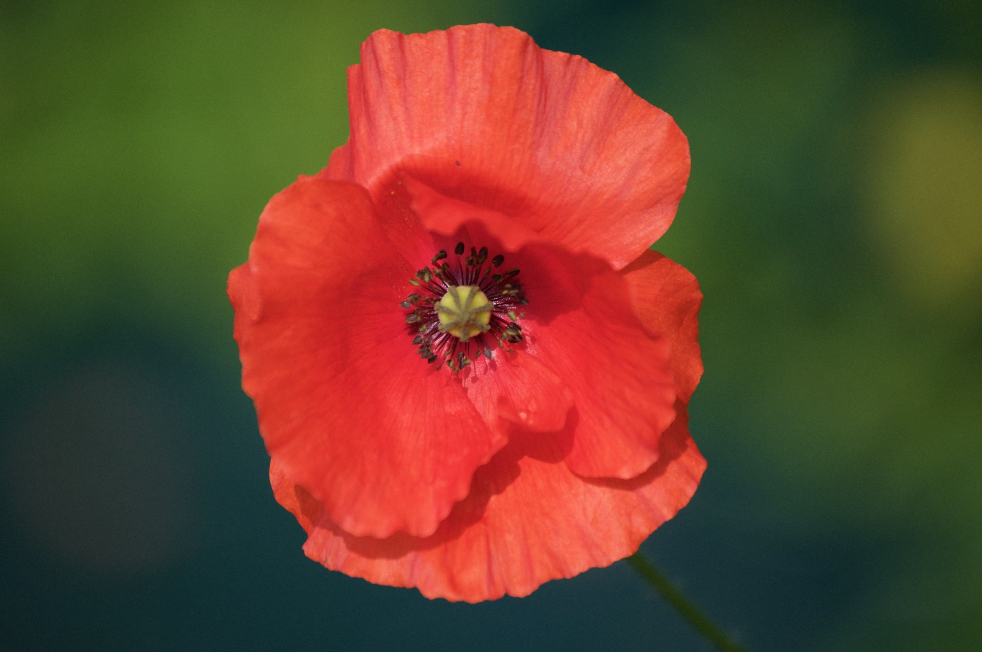Blairgowrie Advertiser 18 September 1920-
IMPRESSIVE CEREMONY AT KIRKMICHAEL
One of the most impressive and touching scenes ever witnessed at Kirkmichael took place there on Sunday afternoon in connection with the unveiling and dedication of the cairn erected to the memory of the men of Strathardle who made the supreme sacrifice in the Great War.
When the question of a memorial was being first considered, the form of a cairn was thought to be the most appropriate to the district and to the men who gave their lives, and as being the traditional Scottish memorial to a warrior who fell in battle.
The site decided on was the high knowe at the east end of the glebe, adjacent to the highway shortly before entering the village, and was kindly granted by the heritor of the parish.
The cairn built of boulders off the land on which the fallen lived and worked, and was put up by the hands of the people themselves. To gather in the stones three love dargs were held during the spring and summer, these being heartily supported by everyone who was asked to help. The boulders, some of them of considerable size, are cemented together, and form a pile 11 feet high, surmounted by an immense slab of stone 13 feet high, two feet of which is imbedded in the centre of the cairn. This huge block was brought from Kindrogan. The actual height of the monument is thus 22 feet.
On the front of the cairn is a tablet of brass engraved in Celtic lettering, with a Celtic cross in the centre, and a Celtic scroll round the margin. The inscription reads:-
To the Glory of God
JAMES BLAIR, BLACKMILL
WALTER BURNETT, ASHINTULLY
GEORGE CLARK, BALNABROICH
DAVID DONALDSON, MERKLANDS LODGE
DAVID GORDON, MILTON OF DOUNIE
ALEX. M’DONALD, ASHINTULLY
PETER MITCHELL, BANNERFIELD COTTAGE
HARRY MORRISON, U.F. CHURCH MANSE
JAMES ROBERTSON, MERKLANDS
DAVID ROBERTSON, WESTER TULLOCHCURRAN
EDWARD ROBERTSON, DALNABRECK
ALEX. SLOAN, KIRKMICHAEL
ALEX. STRAITON, DALNAGAIRN
Men of Strathardle who fell in the War
1914 – 1919
This to their Memory
and
In Honour of All who served.
The cairn and tablet were designed by Mr Don. Mackie, Coltbridge Studio, Edinburgh, and the practical work of building the cairn was carried out by Mr James Gordon, mason, Kirkmichael.
The Committee who had charge of the whole erection comprised:- Mr F. Balfour of Kindrogan, Chairman; Lady Stormonth Darling of Balvarron; Rev. James C. Mackay, Parish Church; and Messrs James Small, Kirkmichael; John Stewart Dounie; John Shepherd, Dalnagairn; William Grant, Boreland; John Greig, C.B.E., Courran; Dr Alex. Miles, Cnocsualtach; and Mr W. Richmond, Schoolhouse, Secretary. Since Mr Richmond retired from the school and left the district, the secretarial duties have been undertaken by Dr Miles.
On Sunday, at noon, a joint dedicatory service was held in the parish Church, where a very large and representative congregation assembled. The pulpit was occupied by rev. J. C. Mackay, parish minister, and rev. A. L. Skene, U.F. Church minister, and a combined choir, with Miss M’Gregor at the organ, led the praise. Rev. Kenneth M’Leod, Colonsay, formerly of Straloch, was to have taken part in the proceedings, but, to his extreme regret, he was urgently called home in consequence of serious illness in his congregation. The order of service was:- Psalm xxiii., reading of several appropriate passages of Scripture, prayer, Psalm xx., Old Testament lesson, II. Samuel 1-17; Hymn 332, “Brief Life is Here Our Portion’, New Testament lesson, Revelation xxi. 1-7, the Creed and then the Lord’s Prayer, the congregation standing; and the National Anthem.
Rev. Mr Skene, preaching from Joshua iv. 7 – “These stones shall be for a memorial unto the children of Israel forever”, said that the idea of erecting stones as a memorial of some important event is a very old one, as shown in various places of the Old testament. Let us, he proceeded, think of the memorial by the Jordan erected more than 3000 years ago, and see if there is not some points of resemblance between that memorial and our own one to be unveiled today. First, we are reminded of work done, successfully accomplished. We are glad to think of men who gave themselves for others. The war finished makes us think of work done. All honour to each one of the millions, of many a colour and clime, who had a share in it. Some talked of blunders, but consider the greatness, and is it not wonderful there were not more blunders? Today we have to commemorate that work done. It means sacrifice of life, but in the history of mankind no great work had been accomplished except at a great cost. The history of our land is emphatic witness of this from the days of Bannockburn. “Greater love hath no man than this, that a man lay down his life for his friends”. Secondly, we are reminded of God acknowledged. We honour the memory of those who gave their lives in the war, but most of all, we desire again humbly and gratefully to acknowledge God and give Him the glory for the successful issue of the war. In the memorial to be unveiled today, even before the names of the fallen, there occur these words – “To the Glory of God”. Mr Skene recalled the early stages of the war, when we were at great disadvantage. Perhaps by all the rules of warfare, he said, our enemies should have won, but, time and again, they were held back as by an unseen Hand. Many present must recall instances of individuals preserved as a direct answer to prayer. And on a bigger scale, on the memorable occasion when the enemy seemed to be sweeping all before it, why didn’t they march on Paris and seize the Channel Ports? What held them back in the great push of March, 1918? Let us explain as we like. Not the men, not the munitions, not the aid merely of our allies, and we did value it; not the better arrangements; but the Lord’s power and the Lord’s aid blessing the means. These we want fully to acknowledge today. Apart from Him there never would have been victory. Thirdly, the Jordan memorial invoked God’s help for future work. There are tasks facing us today far more serious than we ever imagined. Let us think that the same God Who helped us in the dark days of March, 1918, can still guide and direct in the labour troubles, in the Irish difficulties, in the Mesopotamian tangle. Statesmen and leaders need support as much as did the generals and officers need help and confidence during the war. The work of reconstruction is before us, and we are face to face with new conditions. The old is passing away, whether will or not. There are civil and political earthquakes. Like the children of Israel when they entered Canaan to the serious work of conquest before them, so after the war and with the memory of the past, we must resolutely set to the new and fresh tasks. If the outcome of the years of anguish through which we have passed meant in the end a better world, a purer life, and a great revival of religion, who shall say that sacrifice has been in vain, or that the blood has been thrown away.
Rev. Mr Mackay then led in prayer, and afterwards read the names of the fallen, the congregation upstanding; and the service concluded with paraphrase ixvi. And the Benediction.
A procession was formed at Kirkmichael Bridge immediately after the service, and marched to the cairn in the following order:- Pipers George Munro, Malcolm M’Millan, and Hugh M’Millan, Kirkmichael, Bugler William Robertson, Cotterton; schoolchildren, under Mr J. B. Anderson, Headmaster, and Miss Gould, Infant Mistress; clergy; relatives of the fallen, many of them carrying beautiful wreaths; members of the Memorial Committee; and the general public. The procession had a most imposing appearance as it slowly wended its way to the music of the ‘Flowers of the Forest’, along the road, which was lined with spectators, many of them from long distances.
It was a stiff climb up the concrete steps from the highway to the cairn, and as the space on the top was limited preference was given to those immediately concerned, the great company of those who formed the procession and the spectators remaining on the roadway below.
The ceremony here was very simple, but nonetheless touching. The unveiling was performed by Mr Lachlan M’Intosh, shoemaker, Kirkmichael, the oldest residenter in the Strath, and the dedicatory prayer was offered by the Rev. Mr Mackay. Thereafter the relatives of the deceased placed their tributes around and on the memorial, the pipers played ‘Lochaber No More’, and the ‘Last Post’ was sounded by Bugler Robertson.
There was a solemn stillness around, save for the murmur of the Ardle as it meandered past the spot, and many were affected by the plaintive music of the pipes and the notes of the soldiers’ requiem. Altogether the day will be a memorable one in the Strath, whose young men responded so nobly to the call of their King and country.
(Edit)
By Stuart Nicholson (18/03/2019)

